School

mysql> create database School;

! Teacher Table
mysql> Create table Teacher (Id int(5) NOT NULL Auto_increment,Name varchar(20),Email varchar(25), Primary Key(id));
mysql> insert into Teacher(ID,Name,Email) values(5001,'Vignesh','vig55@gmail.com'),(5002,'Mythili','mythiliSelva@gmail.com');
mysql> select * from Teacher;

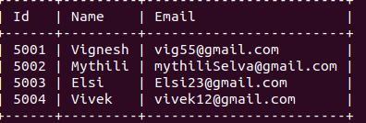

2 Class
mysql> create table Class (ID int(5) Auto_Increment, Name varchar(25),Primary key(ID));
mysql> insert into Class(ID,Name) values(6,'Sixth'),(7,'Seventh');
mysql> Select * from Class;
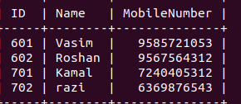

3 Student
mysql> create table Student (ID int(5) Auto_Increment, Name varchar(25), MobileNumber BigInt, Primary key(ID));
mysql> insert into Student(ID,Name,MobileNumber) values(601,'Vasim',9585721053),(602,'Roshan',9567564312),(701,'Kamal',7240405312),(702,'razi',6369876543);
mysql> select * from Student;

4 Subject

mysql> create table Subject (ID int(5) Auto_Increment, Name varchar(25), primary key(ID));
mysql> insert into Subject(ID,Name) values(1,'Tamil'),(2,'English'),(3,'Maths'),(4,'Science'),(5,'Social');
mysql> select * from Subject;
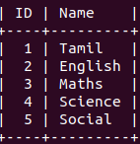

5 marks
mysql> Create table marks (ID int(5) Auto_Increment ,Student_ID int(5), Subject_ID int(5), Marks int(4), Primary key(ID), foreign key(Student_ID) references Student(ID), foreign key(Subject_ID) references Subject(ID));

6 Attendance
mysql> create table Attendance (Id int(5),Student_ID int(5), Date TimeStamp default Current_Timestamp, Attendance int(3), primary key(ID), foreign key(Student_ID) references Student(ID));
mysql> insert into Attendance (Id,Student_ID,Attendance) values(2,602,1),(3,701,1),(4,702,0);
mysql> select * from Attendance;

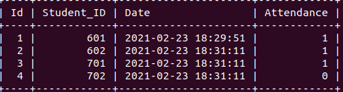

7 SubjectHandling
mysql> create table SubjectHandling (ID int(5) Auto_Increment, Class_ID int(5), Subject_ID int(5),Teacher_ID int(5), primary key(ID), foreign key (Class_ID) references Class(ID), foreign key (Subject_ID) references Subject(ID),foreign key(Teacher_ID) references Teacher(ID));

mysql> insert into SubjectHandling(ID,Class_ID,Subject_ID,Teacher_ID) values(1,6,1,5001),(2,6,2,5001),(3,6,3,5001),(4,6,4,5001),(5,6,5,5001),(6,7,1,5001),(7,7,2,5001),(8,7,3,5001),(9,7,4,5001),(10,7,5,5001);
mysql> select * from SubjectHandling;

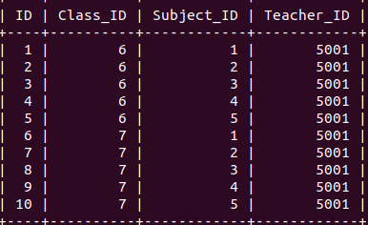

8 ClassStudents

mysql> create table ClassStudents (ID int(5),Student_ID int(5), Class_ID int(5),SubjectHandling_ID int(5), primary key(ID), foreign key (SubjectHandling_ID) references SubjectHandling(ID));

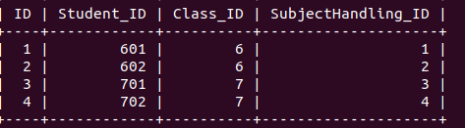

Find the class teacher handle which subject;

ysql> select ClassStudents.Class_ID,ClassStudents.Student_ID,SubjectHandling.Teacher_ID from ClassStudents inner Join SubjectHandling on ClassStudents.Class_ID=SubjectHandling.Class_ID where ClassStudents.Student_ID=601;

(JOINING 3 TABLES)
Find the class teacher which teacher handle which subject then which class have which subjects(joining Tables)

mysql> select ClassStudents.Class_ID,ClassStudents.Student_ID,SubjectHandling.Teacher_ID,Subject.Name from ClassStudents Join SubjectHandling on ClassStudents.Class_ID=SubjectHandling.Class_ID join Subject on Subject.ID=SubjectHandling.Subject_ID where ClassStudents.Student_ID=601;

(
